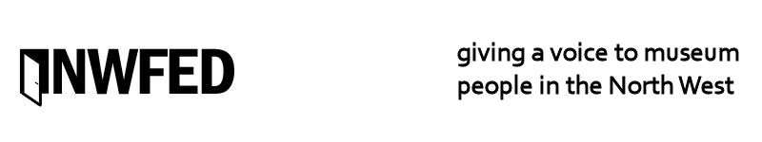
Annual General Meeting of the North West Fed at 10.30am on 27 November 2013 at the People’s History Museum, Manchester

Issue date November 2013

AGENDA

1. Apologies for absence

2. Minutes of the General Meeting held on 1 November 2012

3. Matters arising from the minutes.

4. Report & Financial Statements for the year ended 31st March 2013

5. Ratification, Retirement and election of Members of the Board of Directors

By order of the Board of Directors

